Lab 12: Class Templates, General, Partial, and Complete Specialization
Covering Lectures: 34 - 36
Objective:
This Lab aims to give students a deep understanding of General, Partial, and Complete Specialization concepts.
Learning Outcomes:
After completing this lab, students can practice General, Partial, and Complete Specialization in programs.
Part a.
Problem Statement:
Write a C++ code for a generic class “Container” that stores two values of potentially different types. The goal is to demonstrate:
- Complete Specialization for Container when both values are bool. This specialization should handle Boolean-specific logic, such as counting how many true values are stored.
- Partial Specialization for Container when one value is always an integer. This should enable additional operations, like comparing the two values.
Tasks:
Implement the following:
- A general Container class template that stores two values of types T1 and T2.
- A complete specialization for Container<bool, bool> that adds a function countTrue() to count the number of true values stored.
- A partial specialization for Container<int, T> (when one value is always of the type int and the second value can be of any data type), which adds a method isEqual() to check if the two values are equal or not.
- All classes should have print() function to display the values of the variables on the screen.
- Write a main() function to demonstrate the general template, partial specialization, and complete specialization according to the sample output as given below.
Sample Output:
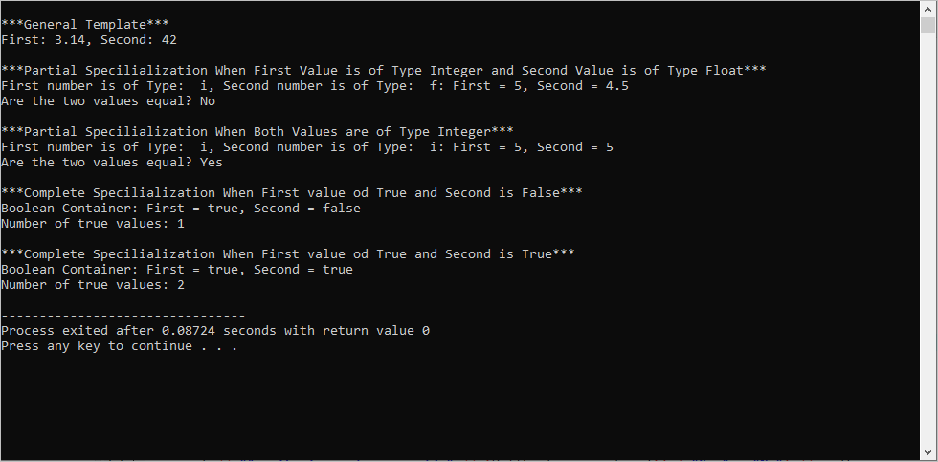
Practice Questions:
- Write a C++ program to manage different types of delivery vehicles. You have to write
  - A generic template for deliveryvehicles with two values of types “VehcileType” and “FuelType” and a print () function. The print () function will display the line “General Delivery Vehicle”, the name, and the fuel type of the vehicle.
  - You want to handle trucks differently from other vehicles so write a specialized deliveryvehicles class for Trucks and FuelType and a print () Function. The print () function will display the line “Truck Delivery Vehicle”, the name, and the fuel type of the vehicle.
  - You want to handle electric bicycles in a completely specialized way, as they are a special case compared to other vehicles.

